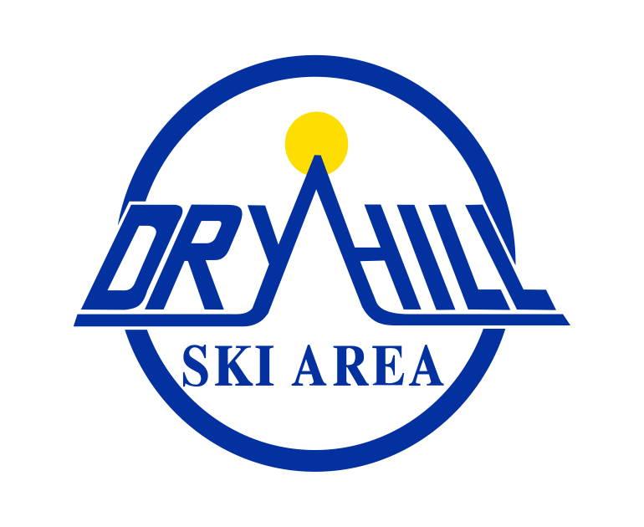
Summer Farmer’s Market 2023

VENDOR INFORMATION AND APPLICATION

Dry Hill Ski Area presents it’s First Annual Summer Farmer’s Market on Sundays,
June 18 - September 24, 2023, from 10am-2pm. We are looking for farm, food, art, clothing, and jewelry vendors to help make this Summer Farmer’s Market unforgettable. Details are listed below. Application deadline is Monday, June 5th, 2023

Summer Market Includes:
• Corn Hole and Frisbee Golf (Free)
• Live Music (designated Sundays)
• Farm Fresh Produce ~ Baked Goods ~ Artists and Crafters ~ Local Food Vendors

VENDOR INFORMATION
• All vending spaces are located outdoors and are based on the approved vendor size specifications.
• Vendors must conduct themselves in a professional manner at all times.
• Vendors are expected to be completely set up by 9am, before the market opens at 10am and must remain on the premises until 2pm, unless the market closes for any reason.
• Vendors who vend all 15 days will be given preference for space.
• Vendors must comply with all federal, state, and local regulations.
• Vendors must call the office at Dry Hill 7 days in advance if you plan to be absent, or in an
emergency, as soon as possible. Please call 315.782.8584
• Vendors are required to bring their own tent, tables and chairs, electrical lead cords, cash and devices required to receive payments. The vendor must be at their booth and keep it clean at all times.
• Vendors are responsible for removing all cardboard/trash/garbage/display items from their site(s). Please leave your space as you found it upon arrival, prior to setup.
• Vendors are responsible for the behavior of themselves, family, and friends.

Please help us promote the event. A Facebook event link will be shared with you as well, and we encourage you to share the event.

If you are a vendor interested in vending at our Summer Farmer’s Market, please complete and return the following vending application by June 5, 2023. Once approved, we will confirm your application and payment via email.

Make checks payable to: Ski Dry Hill, Inc
Mail to: Dry Hill Ski Area, 7379 Martin Road, Adams, NY 13605 Attn: Summer Farmer’s Market

SUMMER 2023 FARMER’S MARKET VENDOR APPLICATION

VENDOR APPLICATIONS ARE DUE BY MONDAY, JUNE 5th, 2023;
ALL VENDORS WILL BE CONFIRMED ON or BEFORE MONDAY, June 12th, 2023.

Please circle the dates you will be vending: 6/18, 6/25, 7/2, 7/9, 7/16, 7/23, 7/30, 8/6, 8/13, 8/20, 8/27, 9/3, 9/10, 9/17, 9/24.

Days Vending | Outdoor Space | Electricity | Total Amount Due
# of Days Vending  ______ | $25.00/day X Number of Days | +$10.00
All 15 days | $275.00 (save $100) | +100.00

Applicant’s Name: ____________________________
Business Name: _____________________________
NYS Sales Tax ID #___________________________
Business Address: _____________________________________________________________
Email address (REQUIRED):____________________________________
Website: ____________________________________________________
Phone number:_________________________________ Cell Phone: ____________________
Type of vending:______________________________________________________________
Plans for vending (what type of items will you be selling, displaying, promoting, please list.):
____________________________________________________________________________
____________________________________________________________________________
• Booth fees are non-refundable in the case of inclement weather or if the vendor cancels.
• Booth fees are only refunded (or prorated) if Ski Dry Hill, Inc. cancels the event.
• Ski Dry Hill, Inc. reserves the right to make changes to booth locations and/or cancel the event for any reason.
• Ski Dry Hill, Inc. reserves the right to deny applications for any reason. If an application is denied, a refund will be issued.

Make checks payable to:Ski Dry Hill, Inc.

Mail to: Dry Hill Ski Area, 7379 Martin Road, Adams, NY 13605 Attn: Summer Farmer’s Market

IMPORTANT INFORMATION

SET UP AND TAKE DOWN
• Please check in at the Ticket Office at 9:00am in the Main Lodge.
• Set up is from 9:00am-10am; We will be opening the parking lot at 9:30am for the event. Please have your space ready by 10am.
• You will be able to drive into the roundabout by the Main Lodge to unload. After unloading all vendors are required to park in the main parking lot.
• Take down is from 2 - 2:30pm. Please do not begin packing up until 2pm.
PERMITS & INSURANCE
• If selling food or beverage, you will need the proper permits. We will require a copy of your permits with the application. If you are unsure about the proper permit to obtain, please contact us.
• If selling items, you will need to register to collect sales tax and display your Certificate of Authority in your booth.
• Proof of insurance is required, with Ski Dry Hill, Inc added as additionally insured. Please submit a copy of your policy with this application.

RULES, REGULATIONS & DEFINITIONS
NON-PROFIT BOOTH: A non-profit booth is defined as any organization that has a 501(c)(3) tax-exempt letter. A copy of your tax-exempt status must be attached to your application.
CRAFT BOOTH: An arts and crafts booth is defined as only handmade crafts made by the booth holder.
• Ski Dry Hill, Inc. is not responsible for any loss or damages.
• We do not allow any dogs or pets (leashed or unleashed) on the property.

Ski Dry Hill Inc., and Dry Hill Ski Area assume NO responsibility and are hereby discharged from all liability or loss, injury, damage to persons or property while on the premises, before, during and after the hours of the event.

Enclose each of the following documents:
_______Application
_______Copy of Insurance*
_______NYS DOH Permit
_______NYS Sales Tax Certificate

_______I agree to display a valid NYS Sales Tax Certificate of Authority at my booth space at all times.

Ski Dry Hill, Inc. Indemnification Hold Harmless & Insurance Agreement

A. Indemnification & Hold Harmless To the fullest extent permitted by law _______________________________ (Third Party Vendor Name), agrees to defend, indemnify, and hold harmless, Dry Hill Ski Area and Ski Dry Hill, Inc. any other affiliates, members and their members, officers, directors, agents, and employees, heirs and assigns from and against any and all claims, liens, judgment, damages, losses, and expenses, including reasonable legal fees whether civil or otherwise arising in whole or in part and in any manner from negligence, intentional or otherwise, acts, omissions, or breach of contract in connections with the performance of any work by the Third Party Vendor, its officers, directors, agents, employees, and subcontractors, et al.

B. *1. Insurance
a. The Third Party Vendor hereby agrees that it will obtain and keep in force insurance policies to cover its liability hereunder and to defend and save harmless Ski Dry Hill, Inc., DBA Dry Hill Ski Area, in the minimum amounts of $1,000,000 per occurrence and $2,000,000 aggregate for bodily injury & property & personal injury including products & completed operations and general operations and premises liability.
b. Said liability policy shall name “Ski Dry Hill, Inc. & its Members, Partners, Officers & Employees” as additional insured and shall be Primary to any other insurance policies.
c. The Third Party Vendor will obtain and keep in force Workers Compensation insurance and its Employees Liability insurance to the fullest statutory limits (if applicable).
d. The Third Party Vendor shall furnish to Ski Dry Hill, Inc. Certificates of Insurance stating that the aforesaid insurance coverage is in force.

*OR 2. Liability Release – The Vendor accepts all liability for possessions, self and their staff during the Dry Hill Summer Market and/ or Fall Festival, for as long as they are on the property owned bySki Dry Hill, Inc.
The Vendor further agrees that should any damage come to the property that is caused by the Vendor, the Vendor will be responsible for repairs and fees related to said repairs. This form is in lieu of a certificate of insurance naming Ski Dry Hill, Inc. as an additional insured for this (these) event(s).

Applicant’s Name:_____________________________________ Date: __________
Applicant’s Signature: _______________________________________

